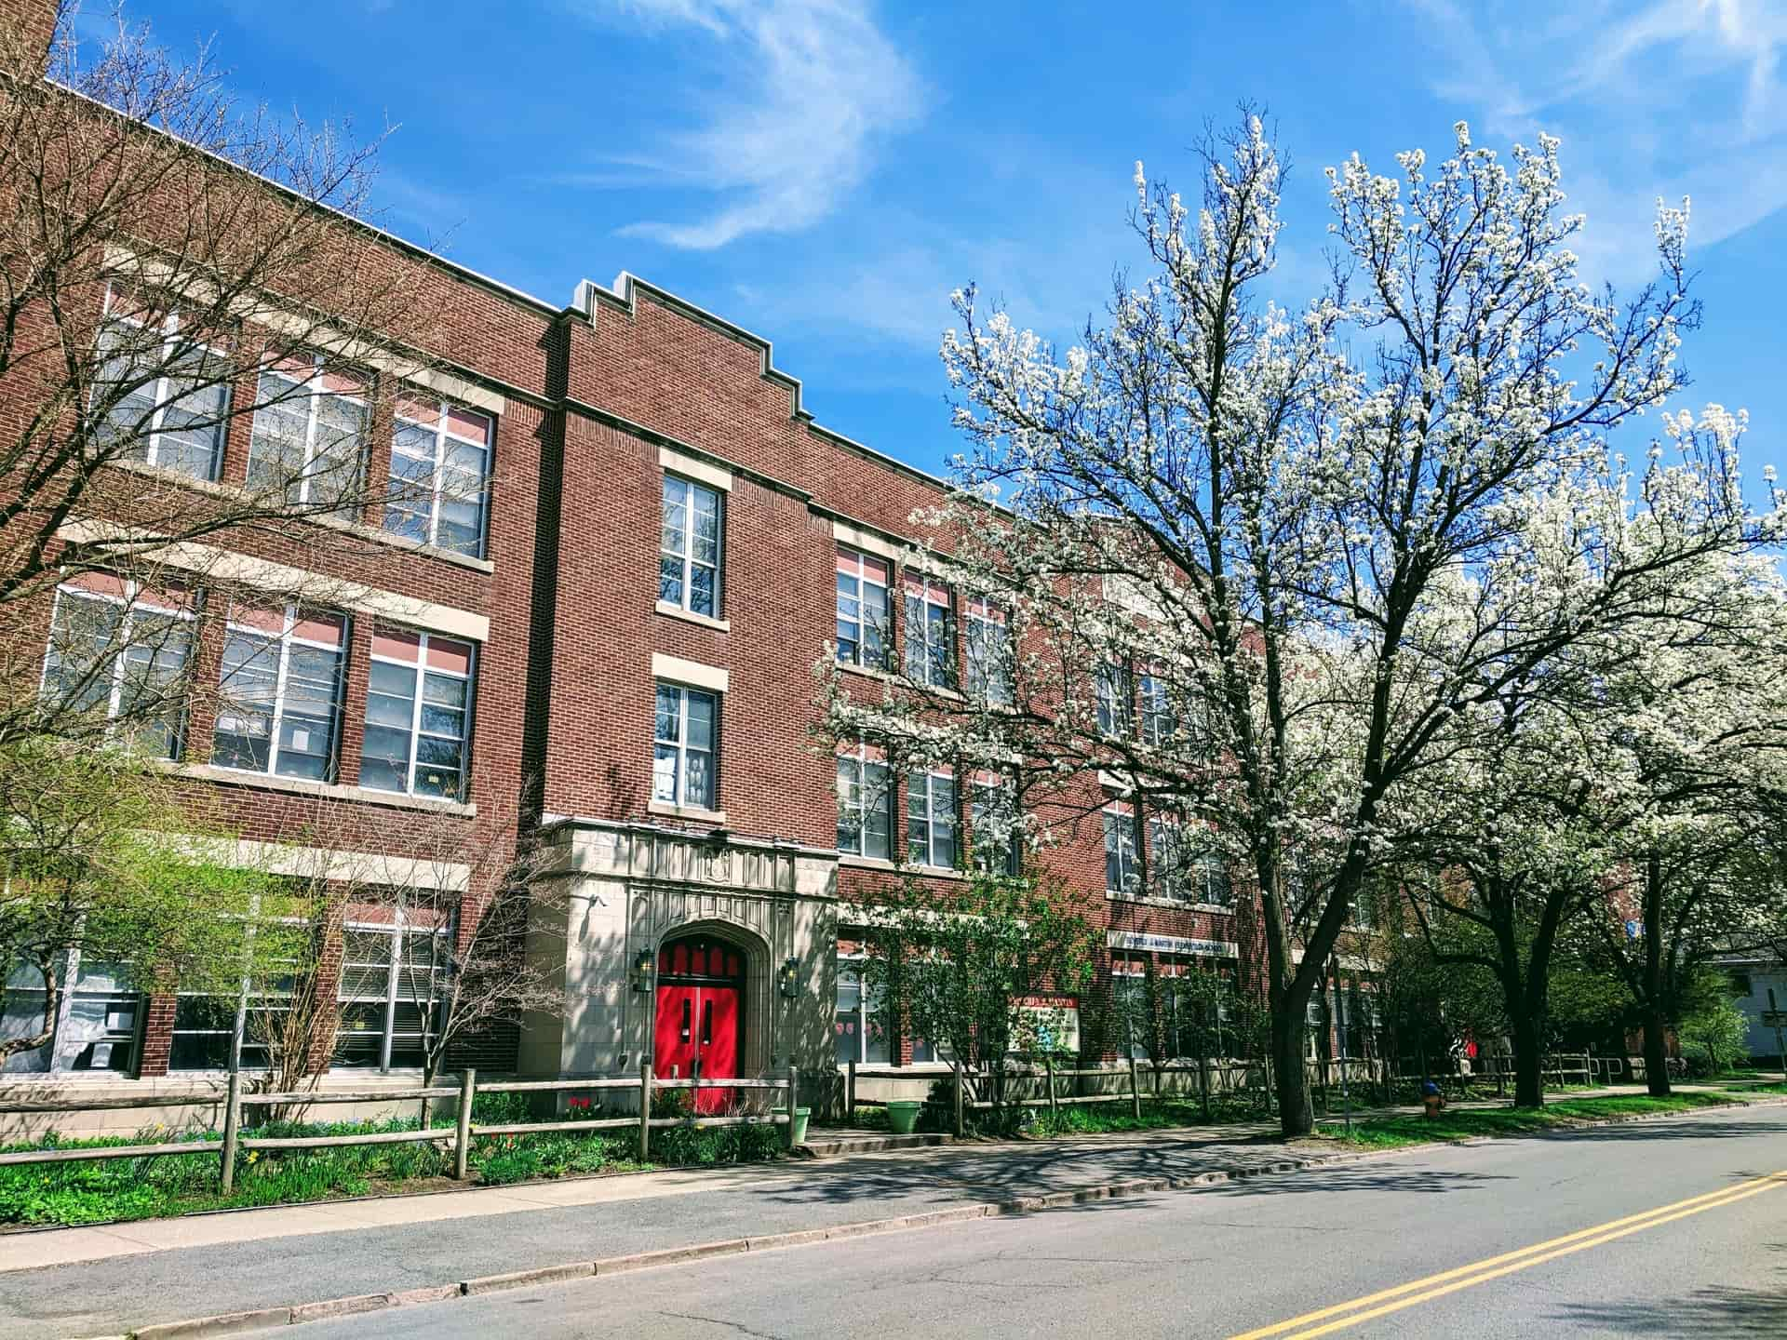

MINIMUM CAPACITY :-
The Minumum intake capacity
of students is between 4000-5200
children

LIBRARY :-
The Libarary is Available.

CANTEEN:-
The Canteen Facility is Available.

BOARDING :-
No availablility of boarding.

SPORTS :-
There are different categories
sports available.
Girls Volleyball
Boys Volleyball
Football

BEVERLY J MARTIN SCHOOL
ITHACA - SCHOOL

School Detail :-
Beverly J Martin Elementary School is a public school located in Ithaca, NY, which is in a small city setting. The student population of Beverly J Martin Elementary School is 268 and the school serves PK-5. At Beverly J Martin Elementary School, 22% of students scored at or above the proficient level for math, and 32% scored at or above that level for reading. Beverly J Martin Elementary School is a public school located in Ithaca, NY, which is in a small city setting. The student population of Beverly J Martin Elementary School is 268 and the school serves PK-5. At Beverly J Martin Elementary School, 22% of students scored at or above the proficient level for math, and 32% scored.

